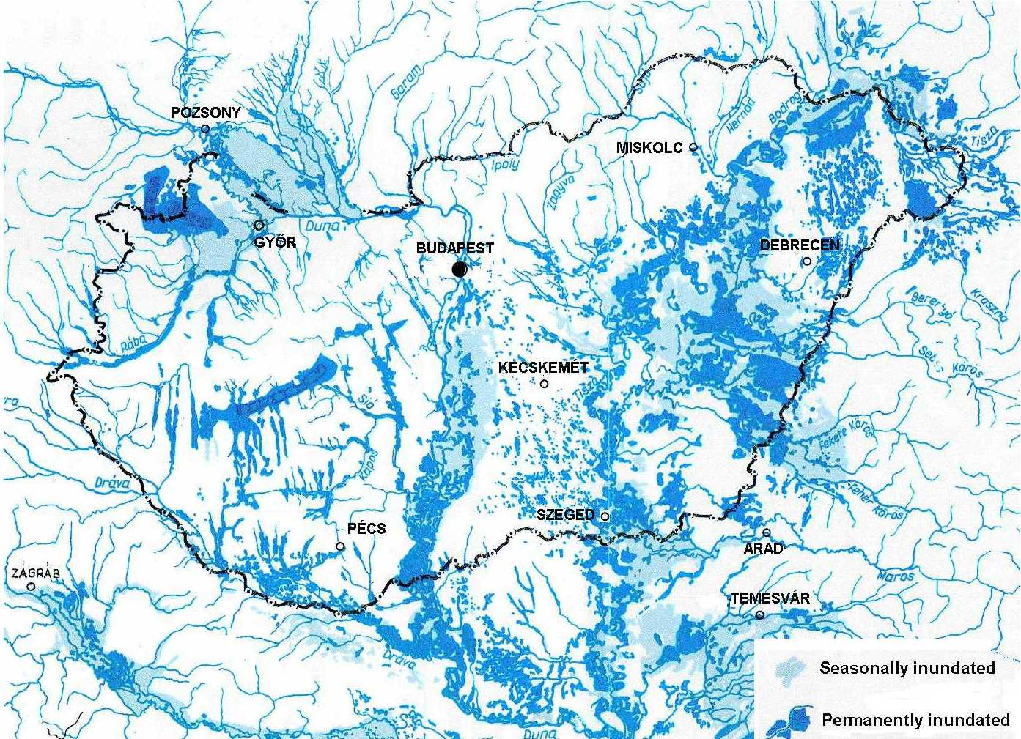
Areas inundated permanently and periodically within the Carpathian Basin prior to the flood control and reclamation project (1830)

