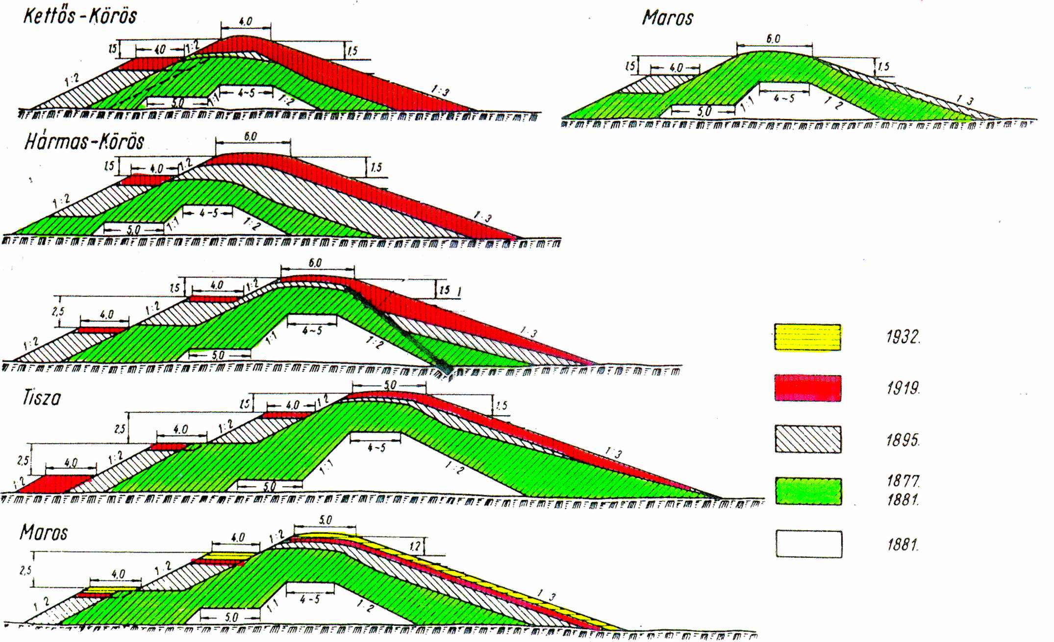

Successive embankment strenghtening along the Tisza and her tributaries

